Week 6
Boyuan Li
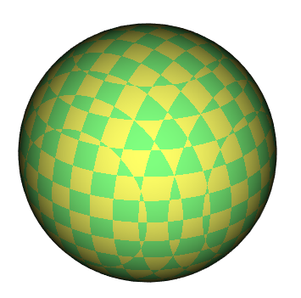
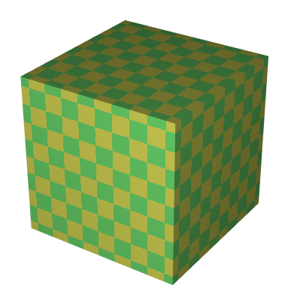

I picked checkerboard since they are easier to notice the pattern. The 3D checkerboard has the most interesting effect when applied on any non-flat surfaces. From the sphere we can guess that the implementation of the 3D checkerboard should be transporting texture from a “block shape checkerboard” into the shape, so it results in such weird behavior. It is more obvious from the shape cone since the bottom of the cone has a nice non-distorted pattern.

